Array
my understanding
o(n) input base pani run agum
10 kudutha 10 times than run agum
O n log n 10 kudutha 33 times runagum
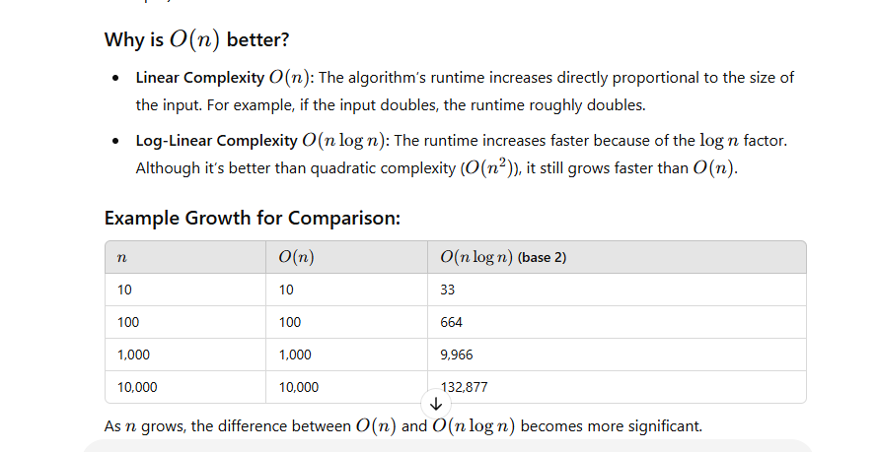

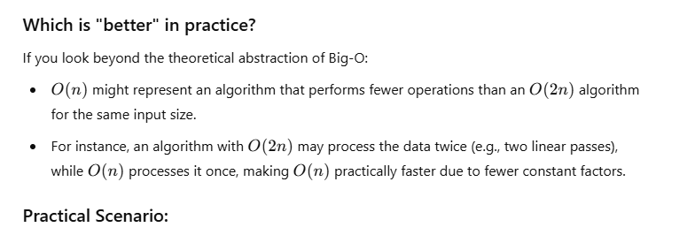

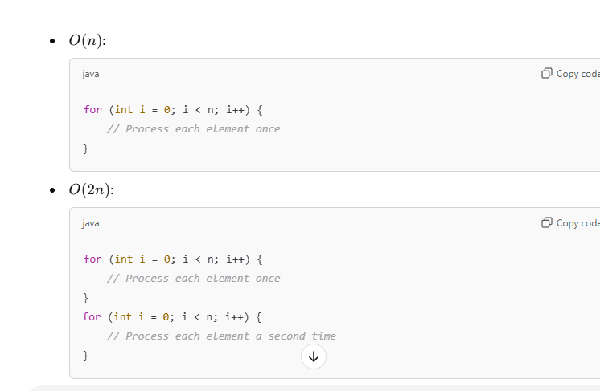

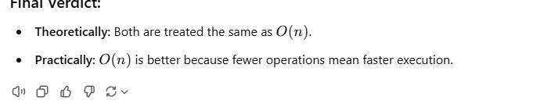

Here I am using variable to temporarily store the current values values.
Largest element in an array ->
logic -> compare the next element in the array . for this u need one for loop and one if statement
Second element in an array -> same as above but for this u need one for loop and one if statement with else . else statement is for find any second largest element present after the duplicate element
Find Second Largest Element in Array | Remove duplicates from Sorted Array | Arrays Intro Video - YouTube
why we are using int second_largest= Integer.MIN_VALUE; en arra la eruka second element or -1 ha eduka kudathu.
You can initialize second_largest as the second element of the array, but it's not always safe to do so. Let's explore why Integer.MIN_VALUE is a better choice in most cases.
Why Integer.MIN_VALUE?
Setting second_largest = Integer.MIN_VALUE; ensures that your program correctly identifies the second largest number even if:
- The array has negative numbers.
- The array is not sorted.
- The second-largest element is before the largest element.
What happens if second_largest = sa[1]?
If you initialize second_largest with sa[1], there are cases where the logic might fail:
- If the largest number appears at sa[0], and sa[1] is not the second largest, your algorithm could return an incorrect value.
- If the array has duplicate largest numbers (like {7, 7, 4, 2, 1}), initializing second_largest = sa[1] might incorrectly assume sa[1] is the second largest when it's not.
Example Failure Case:
Given:
java
CopyEdit
int[] sa = {7, 7, 4, 2, 1};
- If you initialize second_largest = sa[1], then second_largest = 7, which is incorrect because we are looking for the second largest distinct value.
- With Integer.MIN_VALUE, the loop correctly identifies 4 as the second largest.
Conclusion:
Using Integer.MIN_VALUE ensures your program works for all possible inputs. However, if you know your array has at least two distinct elements and is well-formed, initializing second_largest = sa[1] could work, but it introduces risks.
4o
You said:
what if i assign second_largest = -1

ChatGPT said:
ChatGPT
If you initialize second_largest = -1, it might work in some cases, but it's not a reliable solution. Here’s why:
Potential Problems with second_largest = -1
- Incorrect result for arrays with all negative numbers
Example:
java
CopyEdit
int[] sa = {-10, -20, -30, -5};
  - The correct second largest should be -10.
  - But if you initialize second_largest = -1, your logic might never update second_largest since all values are smaller than -1.
  - This would give an incorrect output.
- Incorrect behavior for arrays without negative numbers
Example:
java

- Risk of misleading results when no second largest exists
Example:
java
CopyEdit
int[] sa = {7, 7, 7};
  - There's no second largest element.
  - If you return -1, it could be confusing—did the function return -1 because -1 is in the array, or because there's no second largest?
Why Integer.MIN_VALUE is Better
- Integer.MIN_VALUE is the smallest possible integer, ensuring the algorithm works even with negative numbers.
- It helps detect when no second largest exists, as Integer.MIN_VALUE can serve as an error flag.
Conclusion
Using second_largest = -1 is not a good idea because:
- It may fail for negative numbers.
- It might return a misleading value when no second largest exists.
- It doesn't handle all edge cases correctly.
Using Integer.MIN_VALUE is a better and safer choice because it covers all possible inputs correctly.
4o

Third LARGEST element mela eruka mari than logic extra oru variable use pani store panuva
- MinandMaxelement
Default values set pananum.
Loop ha oda vitutu
if statement la
vara element ha yedhu perusu and smaller check pani antha respective variable la store pananum.

5. SortArray
//just checking previous element is smaller
//if any of the element is greater return false.
One for loop to iterate and one if else statement for check previous element is smaller

6.Removeduplicate-here I am counting the values
one for loop one if statment
7.move to end – same one for loop one if statement before that oru for loop and one if statement for finding the values
8. Rotateanarray-only one for loop
9. Rotateanarray- two for loop – brute force
10. union -logic basic ha oru array la eruka element enour array la eruka element oda
lesser ha nu compare pani add panuren.
oru while loop adhukula oru if statement adhkula oru if else , balance ha erukurathum add panurathu 2 thani thani while loop
11. Intersection-while loop kula oru if ,else if , else – lesser,greater,equalto
12.hasing – one for loop for updating values in new arrar, another for loop for fetching the value from new array and update into variable based on if statement
13. Arrayequal -if statemen, for loop if els, for loop, if else , for loop if
14.sorted 012’s-one for llop for storing values in respective variables, another 3for loop for assigning the respective value in the exisiting array.
15.subset of an array- while if, else if, if . two arrays la value equal ha eruntha next array poren
a array value smaller ha eruku compare to b na appa a la next element erukura element b la presnt agiruka vaipu eruku so next element ku move panuven. Edhu va b greater ha eruntha a la element eruka vaipu illa so false agidum.

